Experiment: 4 To solve a Crypt-Arithmetic problem using Python.
Aim
To solve a Crypt-Arithmetic problem using Python.
Algorithm
- Assign a unique digit to each letter.
- Ensure no two letters have the same digit.
- Convert the words into numbers.
- Check whether the arithmetic equation is satisfied.
- Display the solution if found.
Program
from itertools import permutations
letters = 'SENDMORY'
for p in permutations(range(10), 8):
S,E,N,D,M,O,R,Y = p
if S == 0 or M == 0:
continue
SEND = 1000*S + 100*E + 10*N + D
MORE = 1000*M + 100*O + 10*R + E
MONEY = 10000*M + 1000*O + 100*N + 10*E + Y
if SEND + MORE == MONEY:
print("SEND =", SEND)
print("MORE =", MORE)
print("MONEY =", MONEY)
break
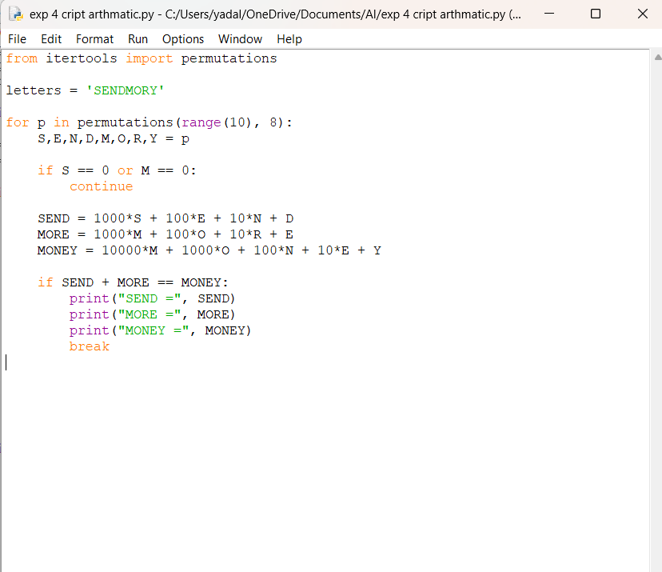
Output
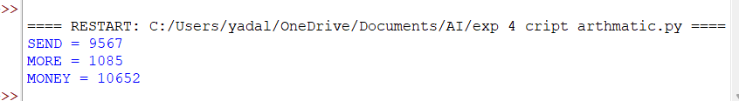Result
The Crypt-Arithmetic problem SEND + MORE = MONEY was successfully solved using Python, and the correct digit assignment was obtained.

